AI Interview Note-Taking Assistant

Sprint 1
4066394
Developer 2
AI Assistant for HR

Nihal Reddy Gaddam

Table of Contents

Purpose and Scope 3
Current-State Interview Note-Taking Process 3
Process Diagram 4
Pain Points and Bottlenecks 5
Current Uses of AI for Interview Note-Taking 6
Potential Opportunities 7
Risks / Assumptions 8
References 9

Purpose and Scope
The Purpose of this research is to explore the current interview note-taking process and identify how AI could potentially support HR professionals during and after interviews.
The research focuses on how interview notes are currently captured manually, reviewed, written up, shared. It will identify difficulties within this process, including split focus, missing information and inconsistent notes.
The research will identify 2-3 real-world AI transcription or meeting-summary tools to understand how existing AI solutions automate note-taking, transcription and summarisation.
The aim is to identify potential opportunities where AI could reduce manual note-taking and allow HR professionals to focus more on the interview itself. At this stage, the research is exploratory and does not propose a final AI solution or confirmed project requirement.

Current-State Interview Note-Taking Process
The current interview note-taking process mainly on the interviewer manually recording important information while conducting interviews. The interviewer needs to listen to the candidate, ask questions, take notes and identify areas that may require follow-up. After the interview, these notes are reviews, organised and prepared before being shared with the relevant hiring team.
Step | Activity | Stakeholder
1 | Interview starts | Interviewer / Candidate
2 | Interviewer introduces the interview and its purpose | Interviewer
3 | Interviewer asks prepared interview questions | Interviewer
4 | Candidate provides answers | Candidate
5 | Interviewer types/writes key points while listening | Interviewer
6 | Interviewer asks for further details or clarification | Interviewer / Candidate
7 | Interviewer finishes with rough/manual notes | Interviewer / Candidate
8 | Rough notes are cleaned and important points summarised | Interviewer
9 | Final notes are saved and/or shared with the hiring team | Interviewer / Hiring Team

Process Diagram
The following diagram provides a visual representation of the current manual interview note-taking process, from the beginning of the interview through to the preparation and sharing of the final notes.
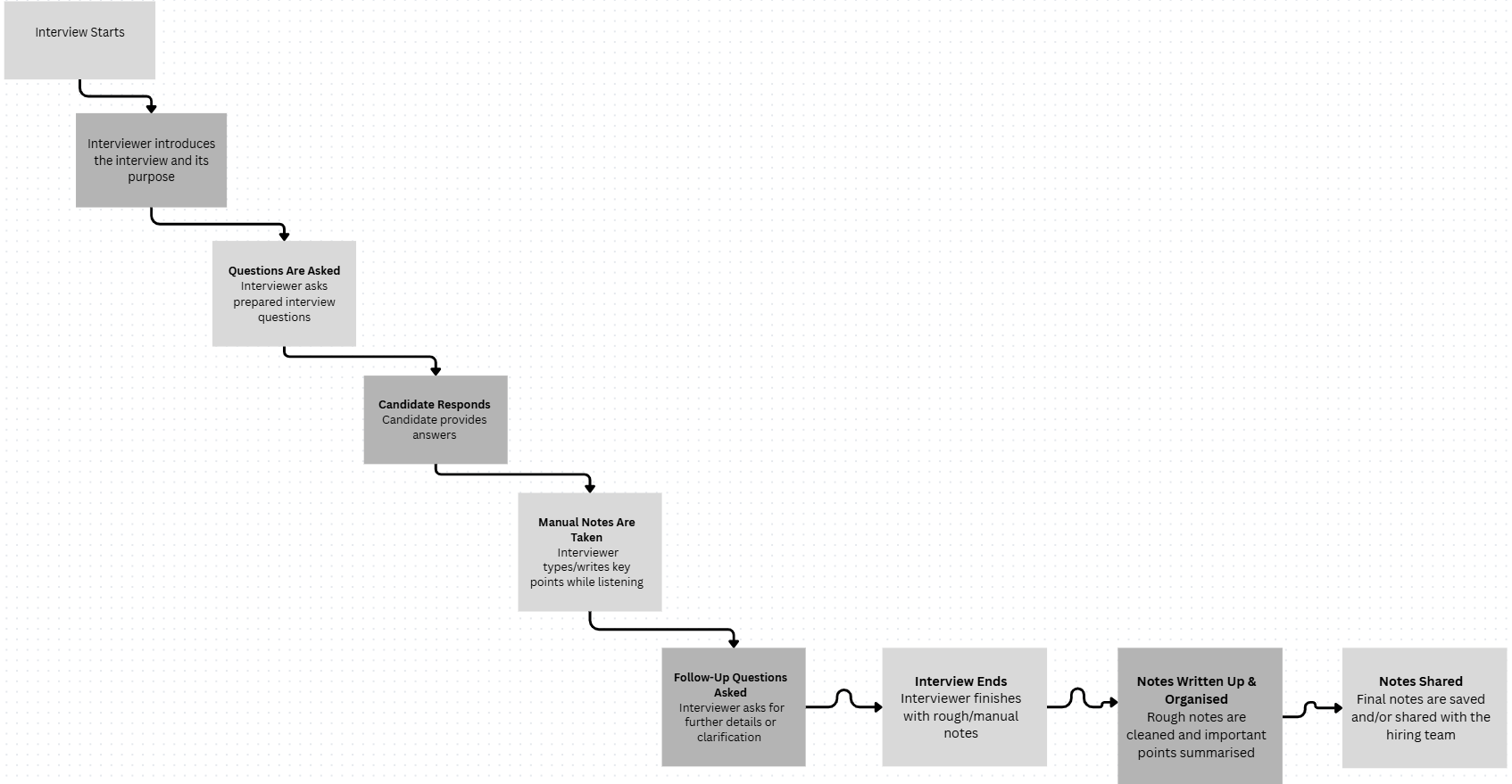
After AI, the number of steps reduced.
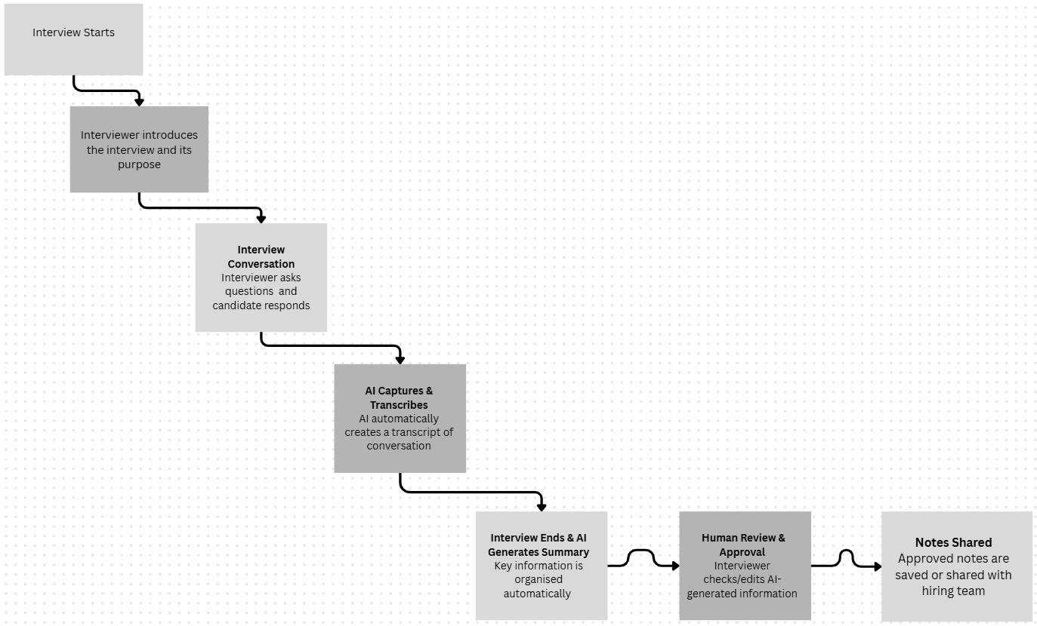

Pain Points and Bottlenecks
Based on the current interview note-taking process, several potential pain points and bottlenecks can be identified. These mainly occur because the interviewer needs to manage the conversation while manually recording information and later preparing the notes for review or sharing.

Pain Point | Current Issue | Potential Impact
Split focus during interviews | The interviewer needs to listen to the candidate, take notes, think about responses and prepare follow-up questions at the same time. | Reduced attention to the candidate and the overall conversation.
Missing important details | Important information may be missed while the interviewer is focused on writing or typing notes. | Interview records may be incomplete and useful candidate information may be lost.
Inconsistent notes | Different interviewers may record different levels of detail or use different note-taking styles. | Interview records may be inconsistent and more difficult for the hiring team to review.
Time-consuming note write-up | Rough notes may need to be cleaned, organised and summarised after the interview. | Additional administrative workload and time is required after each interview.
Loss of context | Short notes or keywords written quickly during the interview may not capture the candidate's complete response. | The interviewer may have difficulty remembering the original meaning or context when reviewing the notes later
Missed follow-up opportunities | Focusing on manual note-taking may make it harder for the interviewer to immediately identify points that require clarification. | Relevant responses may not be explored in enough detail during the interview

Current Uses of AI for Interview Note-Taking
AI-powered note-taking tools are currently being used to capture conversations, generate transcripts and create summaries automatically. These tools provide useful examples of how AI could potentially support the interview note-taking process by reducing the need for manual note-taking during conversations.
- Otter.ai
- Otter.ai is an AI-powered meeting assistant that can automatically transcribe conversations and create a written record of what was discussed.
- The tool can generate AI-powered meeting summaries and identify important information and action items from a conversation. It can also be used with common online meeting platforms such as Zoom, Microsoft Teams and Google Meet.
- These capabilities demonstrate how speech from a conversation can be automatically converted into information that can be reviewed after the meeting, rather than requiring the user to manually capture everything while the conversation is happening.
In this, interview problems like Split focus, missing information, manual note-taking and time required to prepare notes after an interview were addressed.
A similar approach could allow an interviewer to focus more on listening to the candidate and asking relevant questions while the conversation is automatically transcribed and summarised for later review
- Fireflies.ai
- Fireflies.ai is an AI meeting assistant that can record, transcribe, summarise and search conversations.
- After a meeting, users can access the conversation transcript and AI-generated summaries. Fireflies also provides features for reviewing and sharing information captured from meetings
- The ability to automatically transform a conversation into a transcript and structured summary is relevant to interview note-taking, where information currently needs to be manually captured and organised by the interviewer.
In this, interview problems like missing details, inconsistent notes, manual transcription and time-consuming post-interview write-up were addressed.
A similar capability could automatically create an interview transcript and organise important information into a summary. The interviewer could then review the generated information rather than preparing the entire interview record manually.
- Fathom
- Fathom is an AI meeting assistant that automatically records, transcribes and summarises online conversations.
- It provides searchable transcripts, AI-generated summaries and action items that users can review after a meeting.
- Fathom is particularly relevant to the interview note-taking problem because automated capture can reduce the need for a participant to continuously take manual notes while another person is speaking.
In this, interview problems like Split focus, missing important details and the additional effort required to prepare notes after a conversation were addressed.
For an interview process, a similar approach could allow the interviewer to remain more engaged with the candidate while AI captures the conversation and prepares information for the interviewer to review afterwards.

Potential Opportunities
Based on the current interview note-taking process, identified pain points and the existing AI tools researched, several areas could potentially benefit from AI-assisted transcription and summarisation. These opportunities focus on reducing manual work while supporting the interviewer during and after an interview.
Opportunity | Possible Capability | Expected Benefit
Automated transcription | Convert the interview conversation into a written transcript automatically. | Reduce the need for continuous manual note-taking and provide a more complete record of the conversation.
AI-generated interview summaries | Generate a concise summary of the interview after the conversation is completed. | Reduce the time required to manually write up and summarise interview notes.
Structured interview notes | Organise captured information according to interview questions, topics or sections. | Improve consistency and make interview information easier to review.
Key-point identification | Identify important information or key points from candidate responses. | Help reduce the chance of important information being overlooked during later review.
Post-interview review | Allow the interviewer to review and potentially edit AI-generated transcripts or summaries before they are finalised. | Maintain human involvement and allow incorrect or unclear information to be corrected.
Storage and sharing support | Prepare approved interview notes in a format that could be stored or shared with authorised members of the hiring team. | Reduce administrative effort after the interview and make information easier for the relevant team to access.

At this discovery stage, these capabilities are potential opportunities for further investigation rather than confirmed project requirements. Further discussion with the client and team would be required to determine which capabilities provide the most value and are technically feasible within the project scope.

Risks / Assumptions
1. Assumptions
- Interviews involve a conversation between an interviewer and a candidate where important information is currently captured through manual notes.
- Some parts of the interview note-taking process, particularly transcription and post-interview summarisation, could potentially be supported through AI.
- Interviewers would still need to review AI-generated transcripts and summaries before the information is treated as a final interview record.
- Interview information would need to be stored and accessed appropriately if an AI-assisted solution were introduced
- The availability of suitable AI services, organisational systems and integration options would need to be confirmed before implementation.

2. Risks
- Transcription Accuracy
  - AI transcription may incorrectly capture words, names, technical terms or parts of a candidate's response. Poor audio quality or multiple speakers could also affect transcription accuracy.
- AI Summary Accuracy
  - An AI-generated summary may miss important information, incorrectly interpret a candidate's response or give too much importance to certain parts of the conversation. Human review would therefore remain important.
- Privacy and Security
  - Interview conversations may contain personal or sensitive candidate information. Any future solution would need appropriate controls around how interview recordings, transcripts and summaries are processed, accessed and stored.

References
- Otter.ai. (2026). Sales notetaker. https://otter.ai/sales-agent
- Otter.ai. (n.d.). Otter voice meeting notes [Live demo]. https://otter.ai/ai-agent/live-demo
- Fireflies.ai. (2026). AI voice agents that run calls for you. https://fireflies.ai/voice-agents
- Cruz, A. (2021, June 10). How Fireflies helps Clara minimize additional client calls. Fireflies.ai. https://fireflies.ai/blog/how-fireflies-helps-clara-minimize-additional-client-calls
- TranscribeToText.AI. (n.d.). AI transcription services: Transcribe to text audio & video. https://transcribetotext.ai/
- Fathom. (n.d.). Fathom for teams. https://www.fathom.ai/solutions/teams
- Fathom. (n.d.). Fathom integrations. https://www.fathom.ai/integrations

